# Target Metrics

Overall - Accuracy: 0.8100, Precision: 0.8216, Recall: 0.8100, F1: 0.8123

Class-specific metrics:

Carbon neutral(ity) - Precision: 0.7407, Recall: 0.8000, F1: 0.7692

Emissions reduction target - Precision: 0.7308, Recall: 0.7600, F1: 0.7451

Net zero - Precision: 0.8148, Recall: 0.8800, F1: 0.8462

No target - Precision: 1.0000, Recall: 0.8000, F1: 0.8889

# Year Metrics

Overall - Accuracy: 0.7900, Precision: 0.8143, Recall: 0.7900, F1: 0.7970

Class-specific metrics:

2020 - Precision: 0.0000, Recall: 0.0000, F1: 0.0000

2022 - Precision: 0.0000, Recall: 0.0000, F1: 0.0000

2025 - Precision: 0.6000, Recall: 0.6000, F1: 0.6000

2030 - Precision: 0.7000, Recall: 0.8400, F1: 0.7636

2031-32 - Precision: 0.0000, Recall: 0.0000, F1: 0.0000

2032 - Precision: 0.0000, Recall: 0.0000, F1: 0.0000

2033 - Precision: 0.0000, Recall: 0.0000, F1: 0.0000

2035 - Precision: 0.8333, Recall: 1.0000, F1: 0.9091

2040 - Precision: 0.8000, Recall: 0.8000, F1: 0.8000

2050 - Precision: 0.8800, Recall: 0.8148, F1: 0.8462

Net zero - Precision: 0.0000, Recall: 0.0000, F1: 0.0000

No target - Precision: 1.0000, Recall: 0.8000, F1: 0.8889

# Other Metrics

Quote Accuracy: 0.9600

Overall Accuracy: 0.7500

Valid XML Percentage: 1.0000

# Confusion Matrices

Target Confusion Matrix:

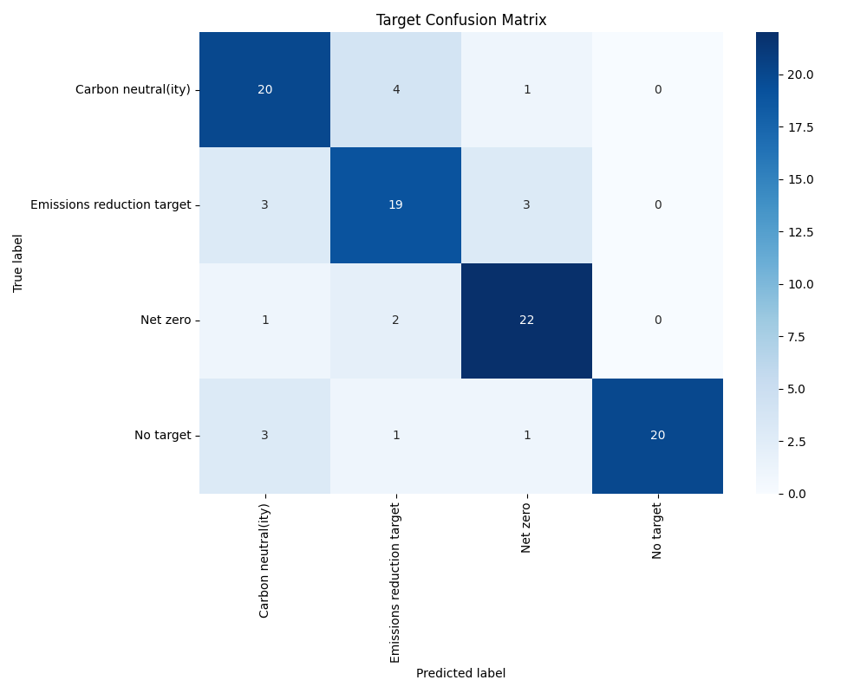

Year Confusion Matrix:

